Hazel Donkin

**Man Ray b. 1890 (Philadelphia), d . 1976 (Paris)**

Born Emmanuel Radnitzky, Man Ray was one of the key innovators in modernist photography, film and object making. He began his artistic career as a painter and his interest in the medium endured although it was primarily photography that brought him financial and critical success. In New York Man Ray was introduced to the avant-garde in visits to Alfred Stieglitz’s ‘291’ gallery and the Armory Show (1913). In 1915 he met Marcel Duchamp and, together with Picabia, these two men founded New York dada. In 1921 Man Ray moved to Paris where he continued to produce experimental and provocative works and was associated with the Paris dada group. Man Ray also developed his lucrative portrait and fashion photography business, photographing cultural giants such as James Joyce and Pablo Picasso and earning commissions from magazines such as *Vogue*. From 1924 photographic images became central in Surrealist publications and Man Ray’s intensely innovative approach was highly regarded by the founder of the group, André Breton. Man Ray developed a poetic that suggested the union of reality and imagination. Man Ray used found images, documentary images, film stills, and straight and experimental photography, including solarisation, a process developed with Lee Miller. World War II forced him to leave Paris for the United States but he returned in 1951 and lived there until his death.

Man Ray’s parents were Russian-Jewish immigrants, they moved to New York in 1897 and Man Ray spent his youth there. After High School he attended art evening classes sporadically and worked as a commercial artist as a technical illustrator for several Manhattan companies. He began to sign his name Man Ray from about 1911, partly due to anti-semitism prevalent at the time. He studied drawing under Robert Henri at the ‘anarchist’ Ferrer School in 1912 and began a period of rapid artistic development. In 1913 he moved to ‘Grantwood’, an artists’ colony in Ridgefield, New Jersey with Samuel Halpert, another student of Henri. There he produced Cubist inspired paintings, wrote and published poetry and drew political cartoons for Emma Goldman’s ‘Mother Earth News’. In 1913 together with Alfred Kreymborg at Grantwood he founded the ‘Others’ art group; participants included William Carlos Williams, Mina Loy and Marianne Moore. The group came into contact with émigré artists who had fled the war in Europe and in 1915 Man Ray met Marcel Duchamp when he joined the colony. The two men would become life-long collaborators and along with Picabia, they founded New York Dada in 1916. The same year, along with Duchamp and Katherine Drier, Man Ray founded the avant-garde exhibiting society, the ‘Societé Anonyme’. Man Ray made objects, collages, assemblages and began experimenting with photography.

In 1921 Man Ray moved to Paris where he became part of the Dada group there. In December 1921 he had a solo show at Librairie Six, the bookshop of Philippe and Mick Soupault. Man Ray recounts the story in his autobiography of how, on the afternoon of the exhibition opening, he bought a flat iron and some nails from a hardware shop while out for a stroll with Eric Satie. He glued the nails to the work surface of the iron to create the object *Gift*, placing it in the show on his return to Librairie Six. Man Ray opened a photography studio and experimented with photographic techniques including photograms (cameraless pictures) which he called ‘Rayographs’; in 1922 he published *Champs Délicieux,* a photographic album of 12 rayographs with a preface by Tristan Tzara. Commissions for portrait and fashion photographs provided him with a steady income and made him wealthy.

When André Breton launched Surrealism in 1924, Man Ray began a long term association with the movement. He produced photographs, original and found, for surrealist journals such as *La Révolution Surréaliste* (1924 – 29) and *Le Surréalisme au Service de la Révolution* (1930 - 33) as well as objects, paintings and films. It was Man Ray who suggested that Eugène Atget’s photographs of Paris were published in *La Révolution Surréaliste* in 1926, recognising them as images of the city as a site of the marvellous. He took on assistants who would become key avant-garde photographers in their own right; Berenice Abbott (1923 – 26), Jacques André Boiffard (1926 – 29) and Lee Miller (1929 – 32). With Miller he experimented with the technique of solarisation, where the image is part positive and part negative. Man Ray’s notable films are *Le Retour à la Raison* (1923), *Emak-Bakia* (1926), *L’Étoile de Mer* (192 8-29), *Les Mystères du Château de Dé* (1929) and, with Duchamp *Anémic Cinéma* (1926). In 1929 Man Ray’s experimental photography was exhibited in the seminal Film und Foto show in Stuttgart. The modified photograph *Le Violon d’Ingres* (1924) is typical of his oeuvre, it transforms the classical nude and is sexually charged. Its tension stems from the fact that it is at once humorous, celebratory and disturbing. It involves word play in the title, suggesting that the woman is a mere ‘hobby’ as well as rape (viol is French for rape). Man Ray was successful as a painter and photographer in Hollywood on his return to the United States in 1940. He returned to Paris in 1951 where he continued to work until he died in his studio at the age of 86.

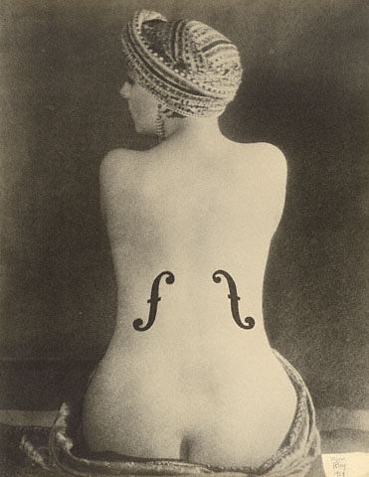

Man Ray, *Le Violin d’Ingres* (1924)

Image from Getty see <http://www.getty.edu/art/gettyguide/artObjectDetails?artobj=61240>

Copyright © Man Ray Trust ARS-ADAGP

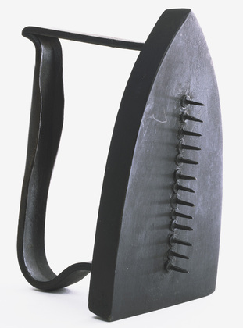

*Gift* (1958 reproduction of 1921 original)

<http://www.moma.org/collection/object.php?object_id=81212>

Credit Line:

James Thrall Soby Fund

MoMA Number:

249.1966

Copyright:

© 2014 Man Ray Trust / Artists Rights Society (ARS), New York / ADAGP, Paris

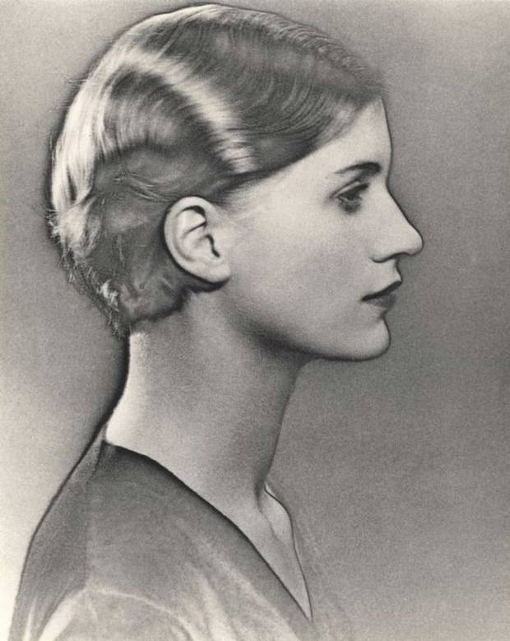

Man Ray *Solarised portrait of Lee Miller* (c. 1929)

© Man Ray Trust/ADAGP, Paris and DACS, London 2012,

Courtesy The Penrose Collection and the Lee Miller Archives (<http://www.leemiller.co.uk/> )

References and further reading

Man Ray (1963) *Self Portrait,* London: Penguin (2012). Man Ray’s autobiography.

Baldwin, N. (2001) *Man Ray: American Artist*, Boston: Da Capo Press. Seminal biography.

Bate, D. (2009) *Photography and Surrealism*, London: I.B. Tauris.

*Duchamp / Man Ray / Picabia*  Exhibition at Tate, London, 21/2/08 – 26/5/08. Extensive and informative internet resource linked to the exhibition at <http://www.tate.org.uk/whats-on/exhibition/duchamp-man-ray-picabia>

Man Ray Trust: Official site <http://www.manraytrust.com/>

You can watch all of Man Ray’s films on Ubuweb, the vast archive of avant-garde media either through this link <http://archive.today/3hZd> or via the main Ubuweb site at <http://www.ubu.com/film/>

Archive of the exhibition of *Man Ray Portraits* at the National Gallery, London in 2013 <http://www.npg.org.uk//whatson/man-ray-portraits/exhibition.php>